Train to Teach with the Sheffield SCITT
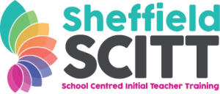
We are proud to be a placement school for the Sheffield SCITT. We work with the Sheffield SCITT to train teachers on their 100% school-based teacher training route. The Sheffield SCITT trains both primary and secondary teachers.
It is more important than ever that we are attracting the best people into the teaching profession and giving them the best possible training.
If you, or anyone you know is interested in training to teach, or simply wants to find out more about teaching as a career, then you can find more information in the Sheffield SCITT prospectus or visit their website. Within school, Matthew Richardson, Deputy Headteacher, would also be very happy to talk to you about this.
The Sheffield SCITT provides two opportunities to find out more about teaching:
The first is an opportunity to register for school experience days. This is a chance to spend a day in a school to see what life might be like as a teacher. You can register either via the Sheffield SCITT website or via the interactive flier below.
The second is an opportunity for university students who are studying a relevant degree to earn £900 undertaking a three week paid internship in a school during the summer term of this academic year. There is more information on how to register in the interactive flier below.

